**Setting Up Your Office 365 Account**

1. 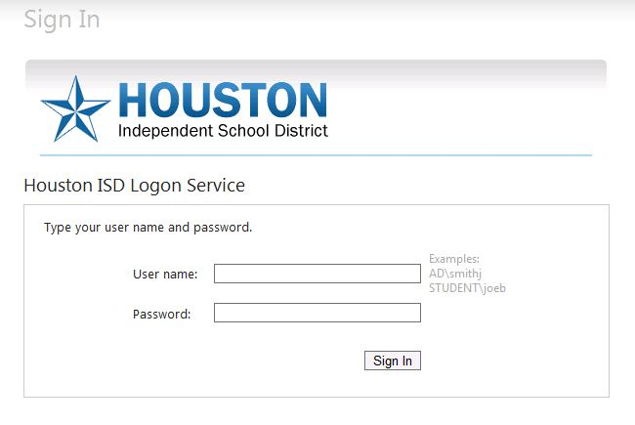Open up Internet Explorer and go to <http://office365.houstonisd.org>.

If you are on the HISD network, you should automatically be logged into the Office 365 site. If you are accessing it from home, you will get the HISD Sign In page. Enter your HISD username and password. If you do not remember your username and/or password, contact the Help Desk at   
**helpdesk@houstonisd.org**.

1. Once you log in, you will be presented with the overview page. Click on the **SkyDrive** link in the upper right toolbar.

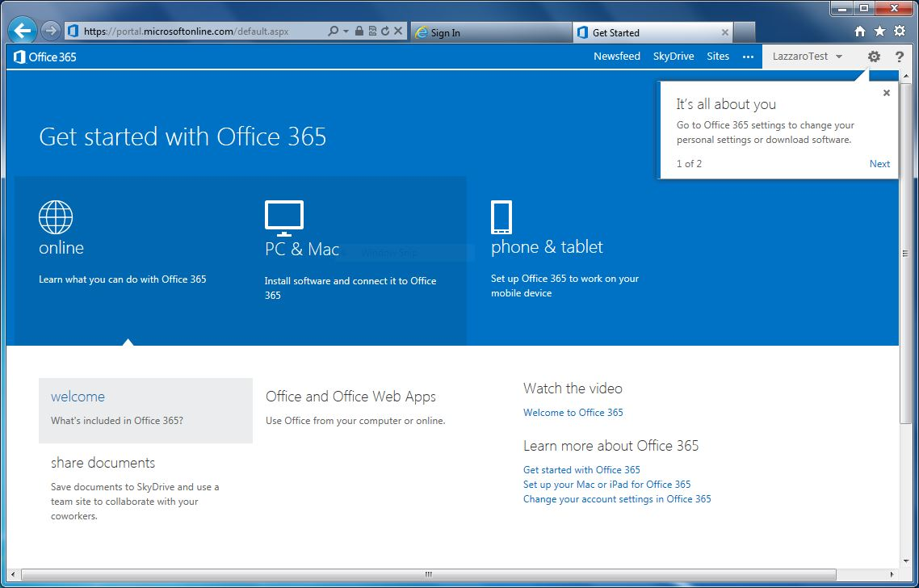

1. When accessing the SkyDrive for the first time, you should see the message that your account is being set up. While most accounts should be ready within a few hours, it can take up to three days to set up your account. If your account does not get past this message three days after you first log in, contact the Help Desk to report the issue.

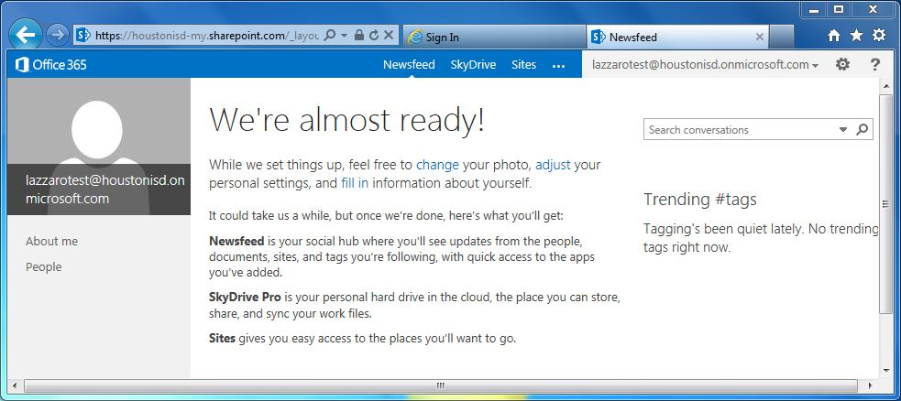

1. When your account has been properly set up, you should see the SkyDrive Documents page.

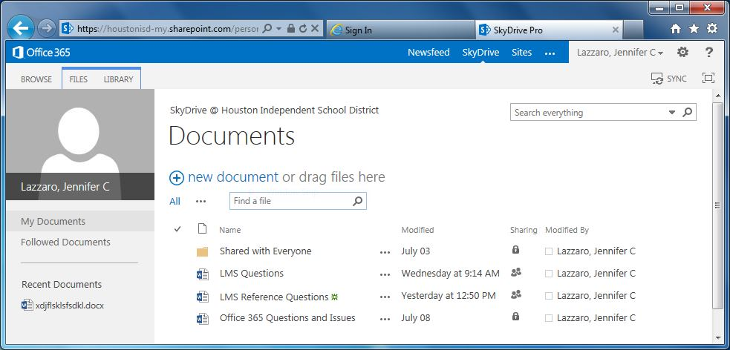

At this point your Office 365 account has been set up and you are ready to start using it. The Instructional Technology team will be providing training on SkyDrive and the other features of Office 365 in the weeks to come. Check with your Instructional Technologist for a schedule of courses.